**Inheritance:**

1] Inheritance is a mechanism of acquiring the features and behaviors of a class by another class.

2] The class whose members are inherited is called the base class, and the class that inherits those members is called the derived class.

3] Inheritance implements the IS-A relationship.

**Types of inheritance:**

1] There can be three types of inheritance in java: single, multilevel and hierarchical.

2] In java programming, multiple and hybrid inheritance is supported through interface only.

**1) Single Inheritance:** When a class inherits another class, it is known as a single inheritance*.*

## 

## Fig. Single Inheritance

## 2) Multilevel Inheritance: When there is a chain of inheritance, it is known as multilevel inheritance*.*

## 

## Fig. Multilevel Inheritance

## 3) Hierarchical Inheritance: When two or more classes inherits a single class, it is known as hierarchical inheritance*.*

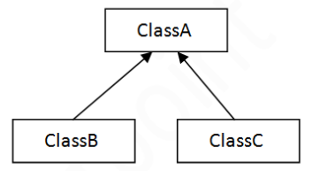

**Fig.** **Hierarchical Inheritance**

**4) Multiple Inheritance:** When derived class is created from more than one base class, it is known as multiple inheritance. This inheritance is not supported by  Java Language.

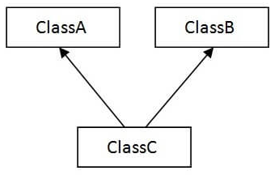

**Fig**. **Multiple Inheritance**

**5) Hybrid Inheritance:** When more than one derived classes are created from a single base class and further child classes act as parent classes for more than one child classes.

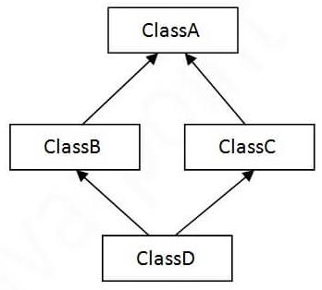

**Fig. Hybrid Inheritance**